Memory book making for someone with
Dementia (and other people too!)
Memory books
We all have had a unique life of adventure and memory books reflect and record our journey.
It's been proven that people with severe memory loss, dementia or Alzheimer's will function better if they are reminded of their lives and those of their loved ones.
A Florida State University researcher found memory books, which might include notes, photos and other keepsakes, can help reconnect dementia sufferers with their loved ones.
Using the memory book may help stimulate the sufferer to use their remaining mental faculties.
It is useful for care givers to be able to connect with an individual’s history and to see them as the whole person.
The Power of Memories
Memories are personal, precious and enduring. It is true to say that if one person holds memories of someone, that person is never really gone. In that sense, memories have enormous power to heal and comfort – and to keep a person alive.
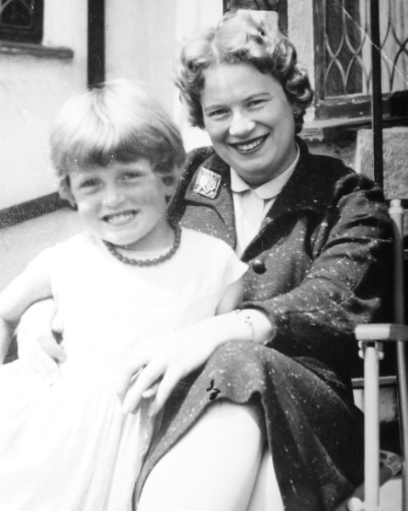
Supplies needed
Either a physical book to put the pictures and descriptions in,
or a digital system of some sort.

I would suggest a book where the pages are able to be removed or added too 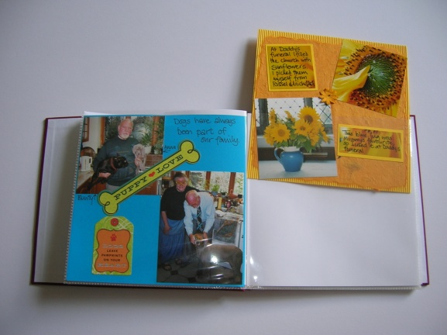

That means you can tailor it to the persons likes and dislikes.
They may get upset by seeing sunflowers because it reminds them of their father’s funeral, that way you can take that page out and slip in something else!

Scrapbooks like this come in many shapes and sizes but 8”X 8” is a good size to start with, they also come in 12” X 12” for the more adventurous or if the person has failing eyesight and you want to make the photos larger.

They are readily available at craft shops, and online
(I found some cheap ones at TK max)

Other alternatives are

Using Photo Books
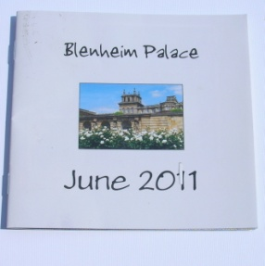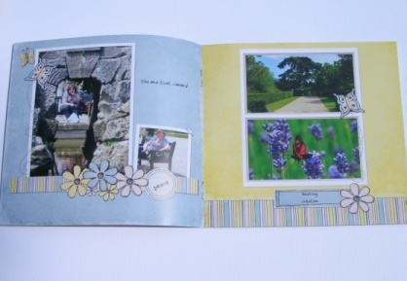
Either online or in store you can make photobooks
There is various software to help create photo book in a few minutes, which guides you through the variety of layouts and backgrounds. More experienced users can use the advanced tools to get all desired looks and effects.
Although in my experience the timing is much understated and you need to allow plenty of time and patience to make one but it’s definitely worth the effort!
They are especially useful to record a day out.
You may just want to make a slide show that can be watched on a laptop or even on an ipad. Scrapbooking software is also available
The photos could have captions added in picasa or using a document making programme

You will also need some of the following items.

Background paper to fit your book

8” X 8” can be bought singly or in co-ordinating packs
but you can also use A4 paper which you can cut to size
and this will also fit in the printer, if you want to print on it at all.

12” X12” is also available from craft stores or online

Glue

I’d recommend using acid free glue if you want the book to last
or double sided tape both are easily gettable you may prefer a
glue stick it’s up to what you feel most comfortable using

Sharp scissors

A guillotine is an option and come in various sizes but not essential

Pens, pencils, an eraser, ruler, craft knife, rubber stamps, paper punches, are also essential

Other things that may come in useful are
You may want to embellish your pages with all sorts of things
e.g. buttons, brads, wire, sequins, paper flowers, ribbon, staples

The list is endless. I personally don’t find “rub-ons” very successful
but peel off embellishments are much easier and stickers are too.
You can pick up lots of bits from pound stores.

There are lots of magazines and books available to give you ideas
As well as information on the internet and on sites like www.youtube.com
A googling you can go!
Include pictures when you can
Here’s a list of suggestions of things to put in your memory book

Name

Birthday (day, month, year, place)

Brothers and sisters (names, birthdays, occupations)

Information about parents

Name and occupation of grandparents and great grandparents if known

What they liked to do when they were little?

Where was their first home?

Where else did they live?

First school, education later on, favourite subject

Occupation

Favourite clothing

Wedding date, memories of that day

Important events in their life

Likes/Dislikes including pets, foods, TV and radio, sports

Health

Hobbies

Favourite songs

Religion / spirituality

Friends

Travel stories

Other family stories

You don't have to have information about all of these.
Just fill in those that are relevant to the person who will receive the book.

Tips on How to choose the right pictures

Make sure your pictures have large faces.
In fact, large pictures are a plus.

Don't feel stupid about filling a page mostly with a picture.
Not only do old people generally have problems seeing, people with dementia also usually have trouble recognizing people.

Having large pictures, or pictures mostly of a face, will help them see the details.
They need to recognize what it's about.

Choose pictures that have a symbolic component.
If your father was a painter, a picture of him painting would be good.
In fact, a picture of anybody painting would still be a good reminder
of what he use to do.

Similarly: pictures of marriage, baptism, graduation etc.
will help spark memories.
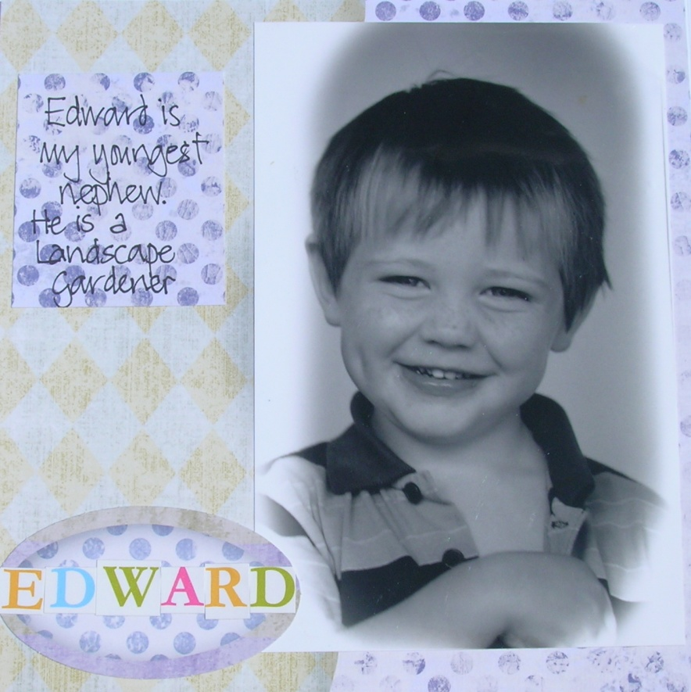

It helps to sort your photos into themes before you start glueing !
You may want to sort them by date, or by person, or activity.
A shoe box with dividers is an ideal way to sort them into their categories,
or you can put them into envelopes, or clear plastic pages.
Tips on how to caption the photos

EACH picture needs to have a caption with the people who are on it.

Don't say, if the page is about Sarah, 'with friend Celia'.
Instead say 'Sarah with her friend Celia'.

The reason is that it is hard for people with Alzheimer’s (or any other kind of memory problem) to connect the dots. They will not automatically know that all the pictures on that page are about the same person. They may not know that several pages are about the same person.

You can put a general heading on the page if you want to
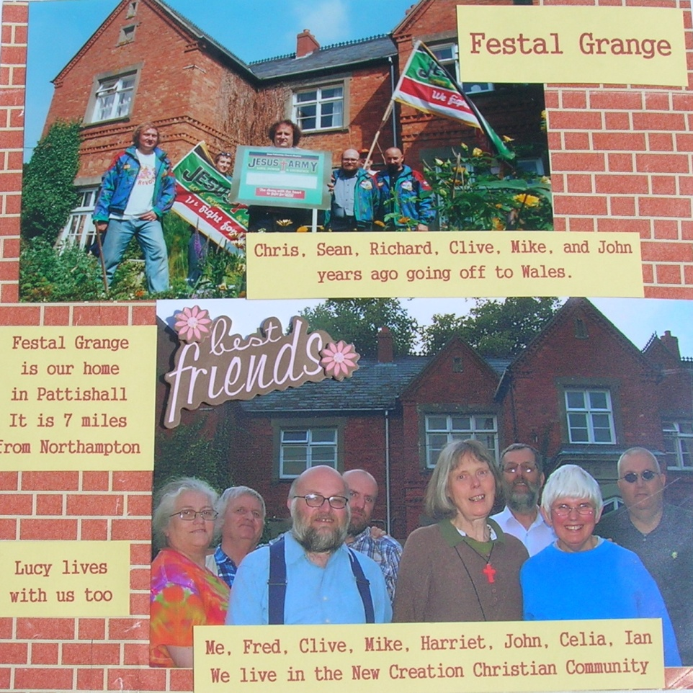

This page illustrates my home and names the people I live with
It also indicates where I live
A talking point when looking at the page is that the house is brick built, which I have reflected in the backing paper

You can print your captions on the printer or you can handwrite them.

Handwriting is such a personal thing, so if it’s to be an heirloom then your handwriting shows the uniqueness of the creator!
I usually do the writing on a separate piece of card or paper so that you don’t spoil your album with spelling mistakes or smudges and then glue it on!!!!
For further information

Do feel free to contact me on 01327 830217

Mobile 07833737851

By email: creativecardsbysarah@yahoo.co.uk

Website: http://creativesarah.weebly.com

By snail mail!
Sarah Veness Festal Grange, 20 Church Street, Pattishall, Northants, NN12 8NB

Facebook: Sarah Veness

Twitter: creativesarahv

Or come along and join us on the last Friday in the month 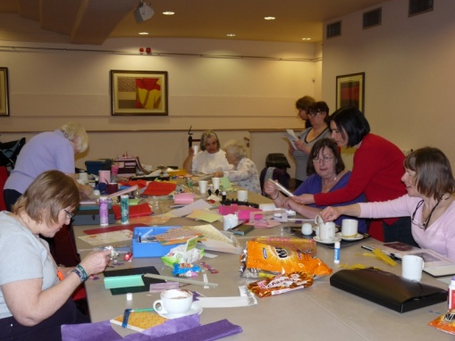 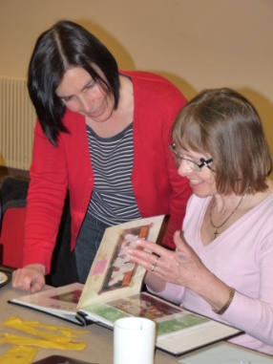

Scrap and Yap Papercraft Group
Scrap and Yap is a friendly, relaxed group. We meet together once a month to encourage, instruct, learn new skills, refresh old ones, and enjoy each other’s company.
We make cards, memory books and scrapbooks, and share our skills and equipment as well as our chocolate!
It's an opportunity to meet with like minded people, and make new friends.
When We meet on the last Friday in the Month
from 10.30am-1.00pm
Where Northampton Jesus Centre
Abington Square
Northampton
NN1 4AE
Cost £2 per session to help towards the running costs
Accessibility Disabled access is through the Deco Entrance
and there is a lift and also a wheelchair lift
Further info Whatever your level of skill from the complete beginner to the most experienced, all you need to bring along on your first visit is a small pair of sharp scissors.

